Manjunath Ole@DESKTOP-BRRH2CJ MINGW64 ~

$ cd

Manjunath Ole@DESKTOP-BRRH2CJ MINGW64 ~

$ cd /d

Manjunath Ole@DESKTOP-BRRH2CJ MINGW64 /d

$ ls

'$RECYCLE.BIN'/ Loadrunner/

_Getintopc.com_FastStone_Capture_8.7/ Manjunatha/

_Getintopc.com_FastStone_Capture_8.7.zip 'Manjunatha - Shortcut.lnk'*

apart/ Manjunatha_Resume_Sm.docx

APK_Files/ MGit/

Ashwini/ mobile/

Ashwini_primary_ACS_DOCS.zip 'Mobile Automation dont delete'/

Automation_Cisco/ NODEJS/

cits-ffdc_RM_APL17/ Office2007/

git/ personal/

hh/ PTE/

ITC/ Python_workspace/

Java_workspace/ Softwares/

'JS Framework'/ 'System Volume Information'/

Learn/ WDIOProjects/

Manjunath Ole@DESKTOP-BRRH2CJ MINGW64 /d

$ Python_workspace/

bash: Python_workspace/: Is a directory

Manjunath Ole@DESKTOP-BRRH2CJ MINGW64 /d

$ ls

'$RECYCLE.BIN'/ Loadrunner/

_Getintopc.com_FastStone_Capture_8.7/ Manjunatha/

_Getintopc.com_FastStone_Capture_8.7.zip 'Manjunatha - Shortcut.lnk'*

apart/ Manjunatha_Resume_Sm.docx

APK_Files/ MGit/

Ashwini/ mobile/

Ashwini_primary_ACS_DOCS.zip 'Mobile Automation dont delete'/

Automation_Cisco/ NODEJS/

cits-ffdc_RM_APL17/ Office2007/

git/ personal/

hh/ PTE/

ITC/ Python_workspace/

Java_workspace/ Softwares/

'JS Framework'/ 'System Volume Information'/

Learn/ WDIOProjects/

Manjunath Ole@DESKTOP-BRRH2CJ MINGW64 /d

$ cd Python_workspace/

Manjunath Ole@DESKTOP-BRRH2CJ MINGW64 /d/Python_workspace

$ ls

Python_Project/ Selenium_basics/ venv/

Manjunath Ole@DESKTOP-BRRH2CJ MINGW64 /d/Python_workspace

$ cd Python_Project/

Manjunath Ole@DESKTOP-BRRH2CJ MINGW64 /d/Python_workspace/Python_Project

$ git config --global user.name "olemanju"

Manjunath Ole@DESKTOP-BRRH2CJ MINGW64 /d/Python_workspace/Python_Project

$ git config --global user.email manju.ole23@gmail.com

Manjunath Ole@DESKTOP-BRRH2CJ MINGW64 /d/Python_workspace/Python_Project

$

Add few files in the Project.

Manjunath Ole@DESKTOP-BRRH2CJ MINGW64 /d/Python_workspace/Python_test (achintya)

$ git status

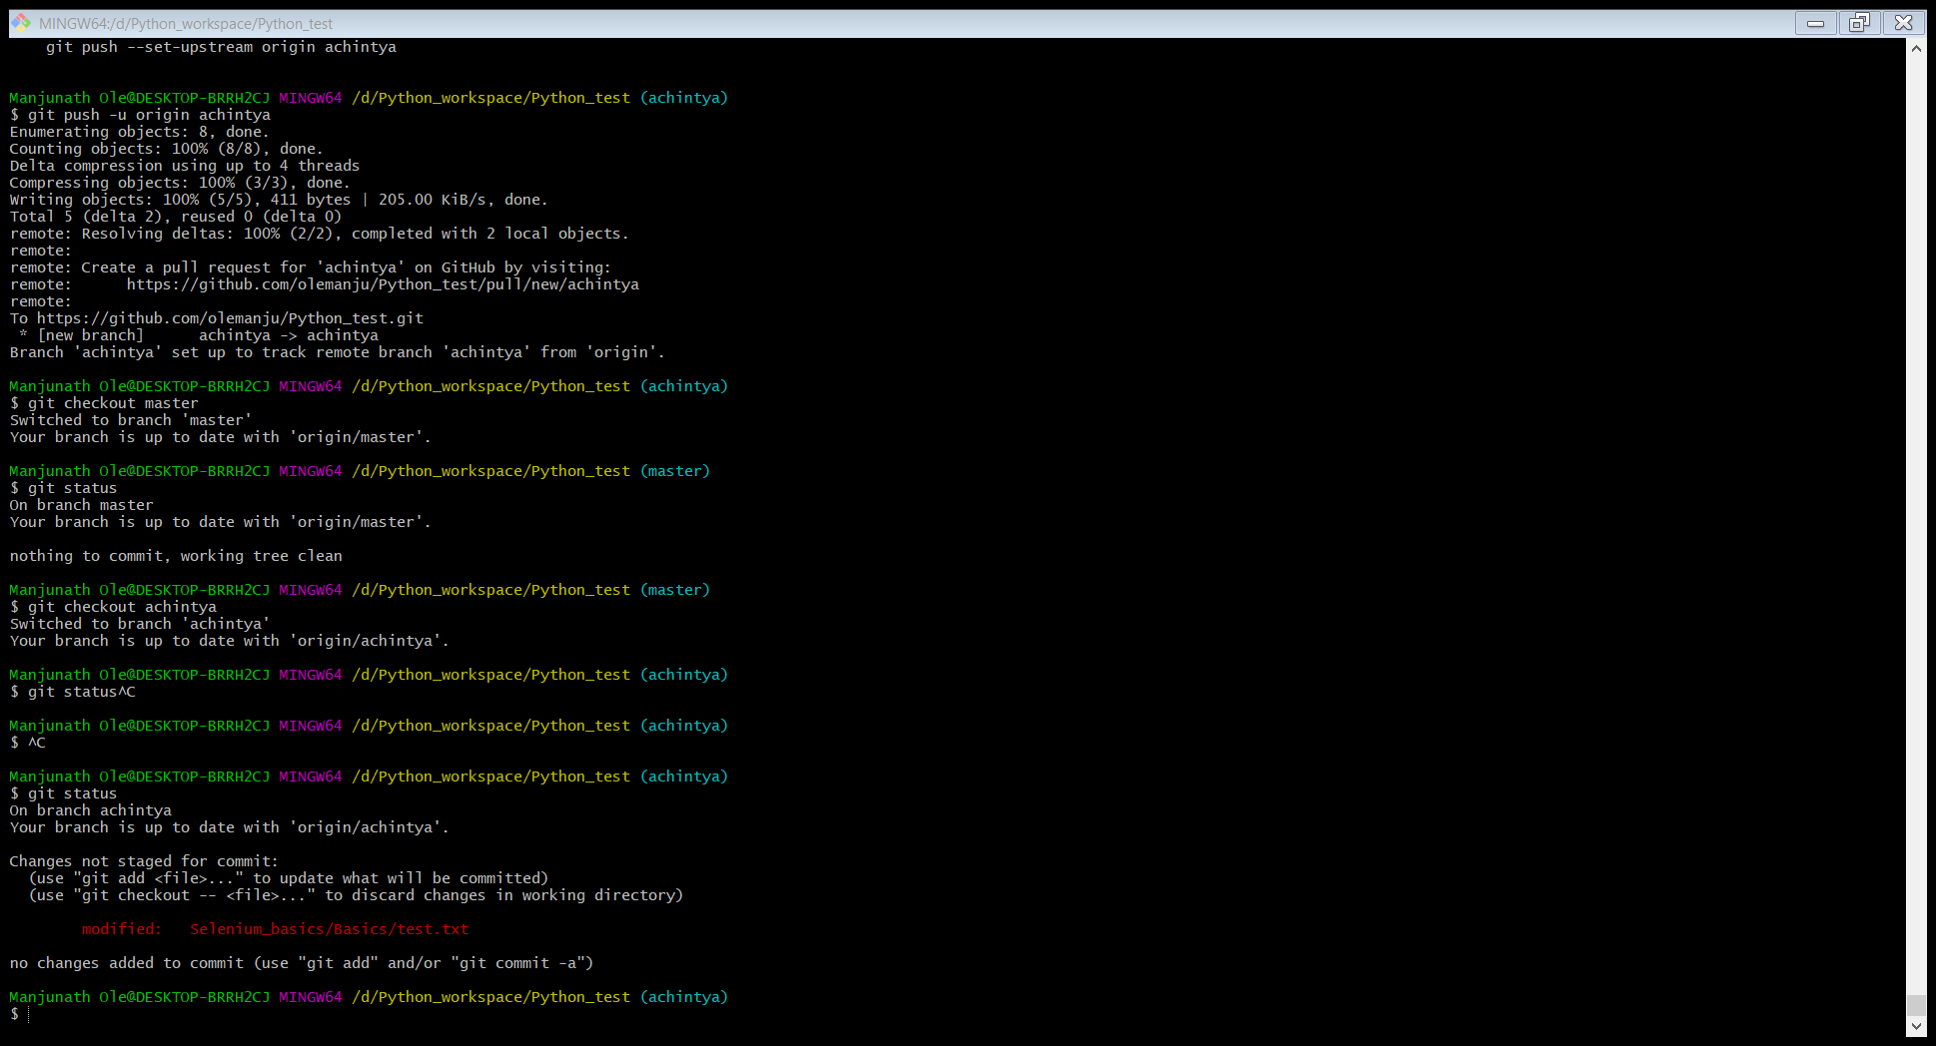

To add all the files to Git

Manjunath Ole@DESKTOP-BRRH2CJ MINGW64 /d/Python_workspace/Python_test (achintya)

$ git add .

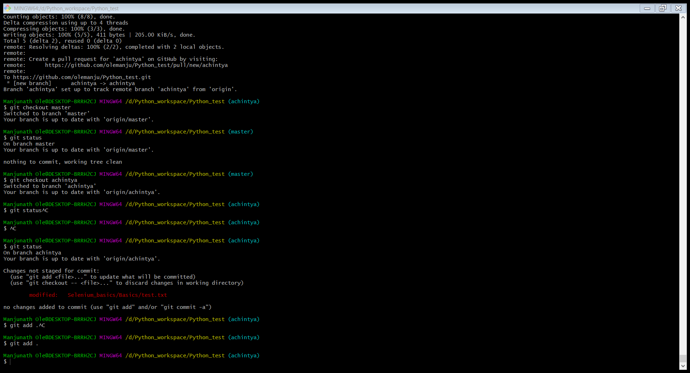

Now check git status-> in the above image. Which are in red . it will turn to Green

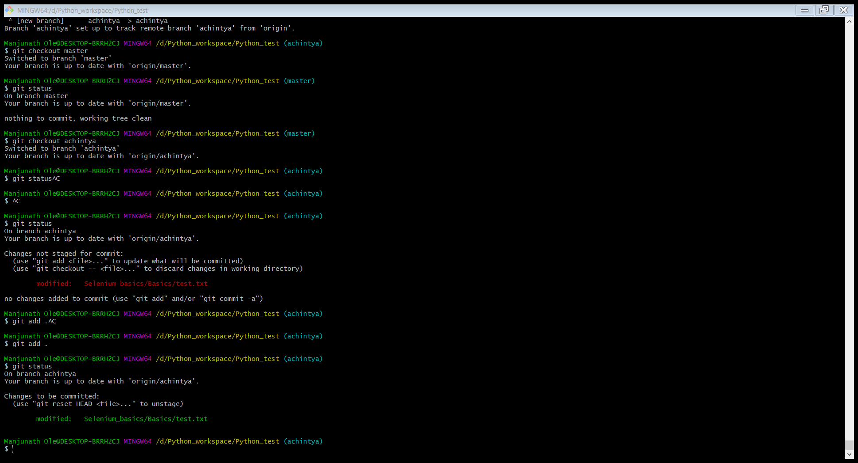

To commit

Manjunath Ole@DESKTOP-BRRH2CJ MINGW64 /d/Python_workspace/Python_test (achintya)

$ git commit -m "This message could be anything"

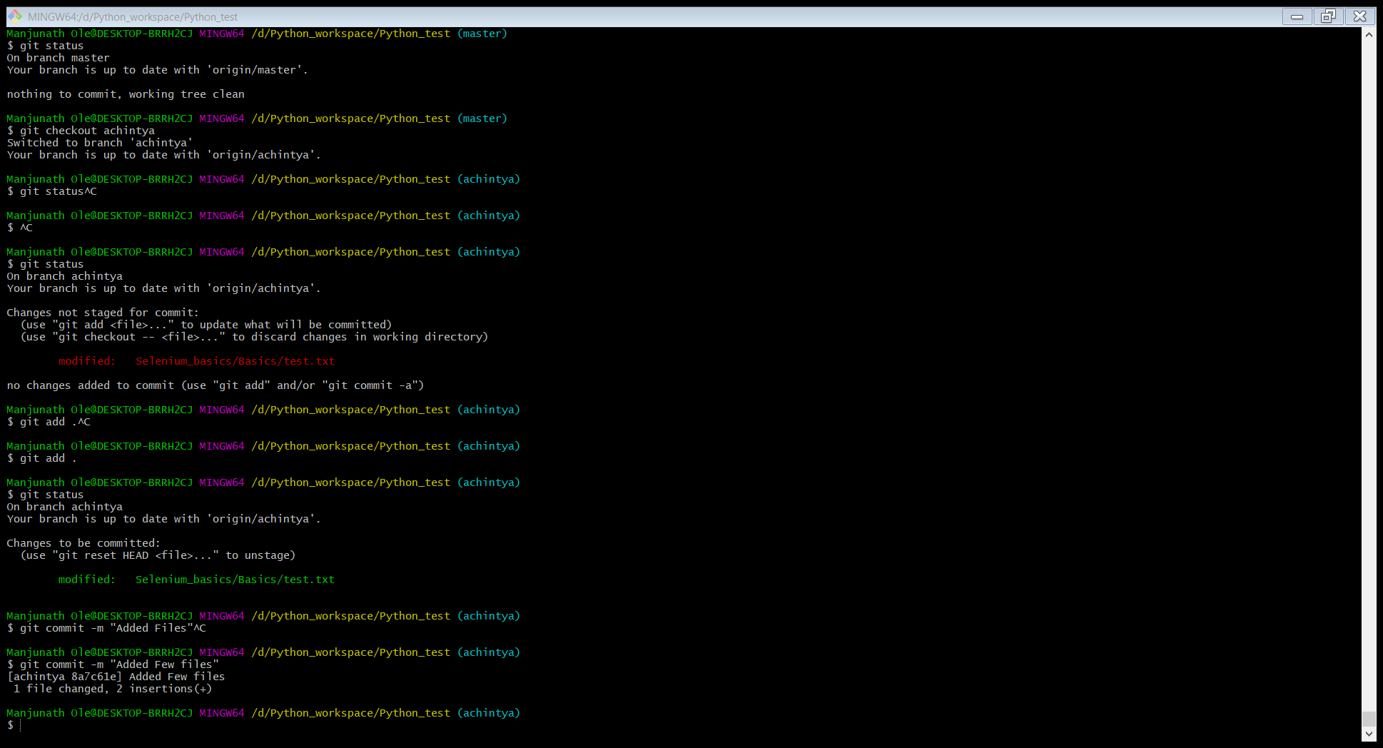

To push the code to Git

Manjunath Ole@DESKTOP-BRRH2CJ MINGW64 /d/Python_workspace/Python_test (achintya)

$ git push -u orign achintya

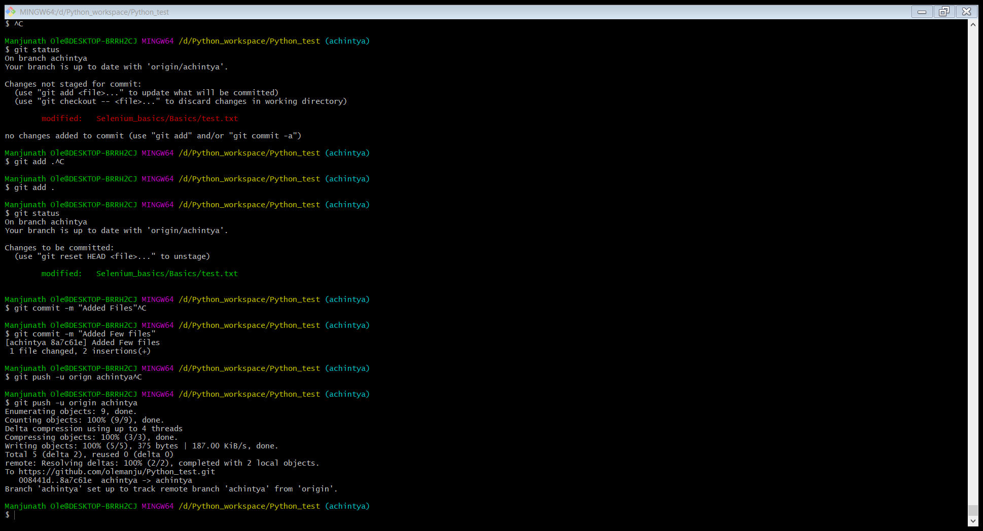

To create a new branch

Manjunath Ole@DESKTOP-BRRH2CJ MINGW64 /d/Python_workspace/Python_test (achintya)

$ git branch moto

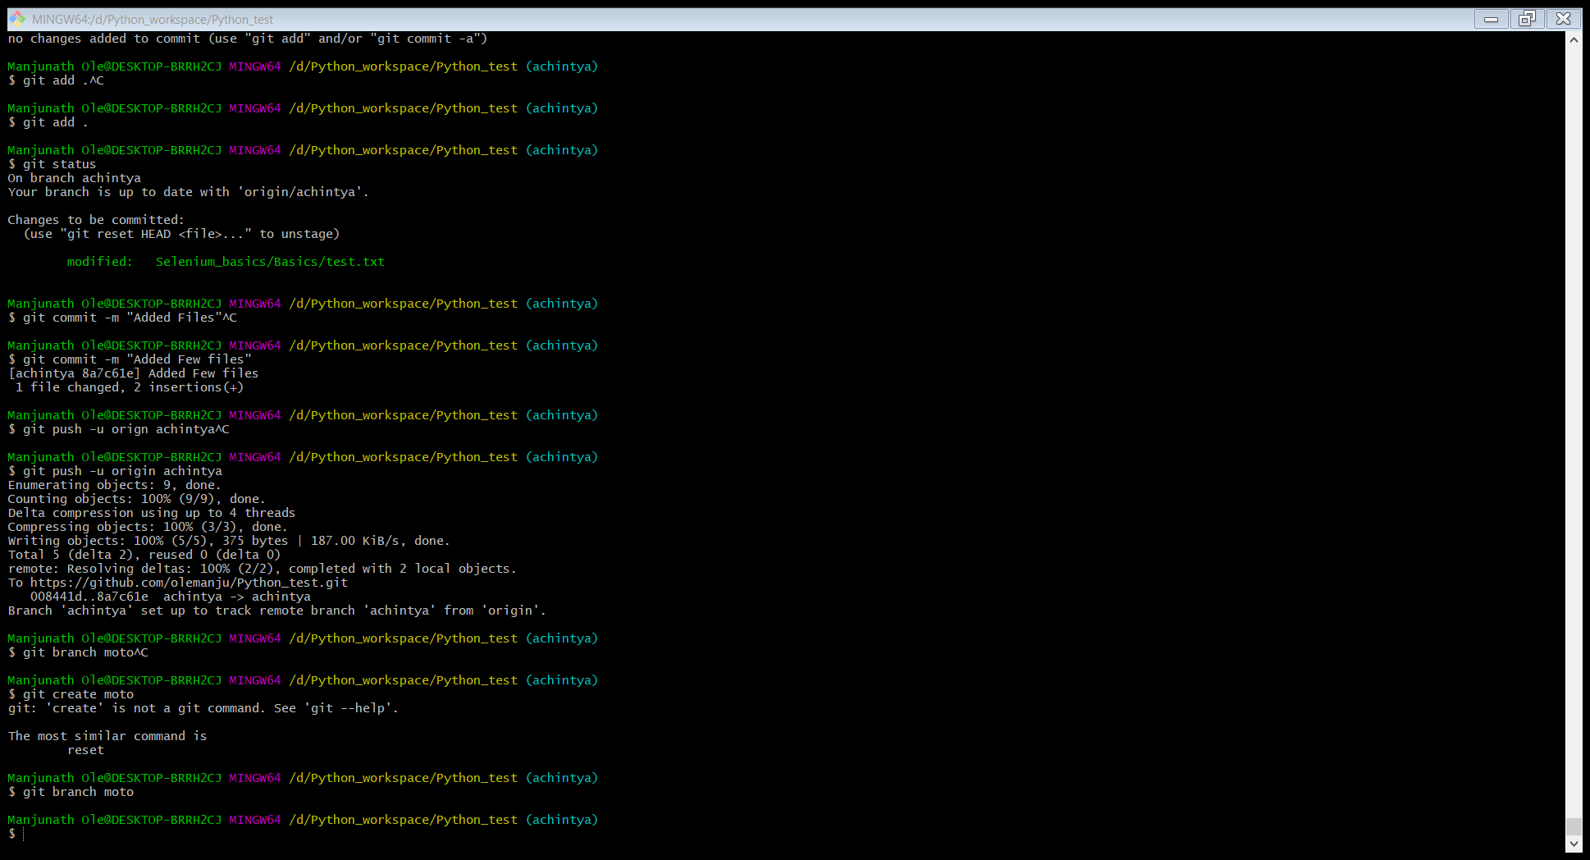

To switch to that Branch

Manjunath Ole@DESKTOP-BRRH2CJ MINGW64 /d/Python_workspace/Python_test (achintya)

$ git branch moto

Manjunath Ole@DESKTOP-BRRH2CJ MINGW64 /d/Python_workspace/Python_test (achintya)

$ git checkout moto

Switched to branch 'moto’

If 2 people are working on the same branch. Then u have to do first Pull then commit and push

Manjunath Ole@DESKTOP-BRRH2CJ MINGW64 /d/Python_workspace/Python_test (moto)

$ git pull

Already up to date.

Manjunath Ole@DESKTOP-BRRH2CJ MINGW64 /d/Python_workspace/Python_test (moto)

$

Manjun

